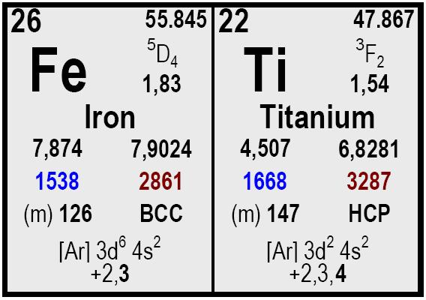

Element | Grade A | Grade B
Ti | 68 – 72 | 68 – 72
Si | 0,50 max. | 0,25 max.
C | 0,20 max. | 0,15 max.
Cu | 0,30 max. | 0,15 max.
Al | 5 max. | 0,5 max.
Cr | 0,5 max. | 0,20 max.
P | 0,03 max. | 0,02 max.
Sn | 0,50 max. | 0,50 max.
N | 1 max. | 1 max.
Ni | 0,50 max. | 0,50 max.
S | 0,03 max. | 0,02 max.
V | 3,50 max. | 0,25 max.

All our products shall be labelled with product name, reference number and net weight. Each delivery is accompanied by a certificate of analysis and the delivery note.

Size Packaging
Delivery time Remarks

Ferro Titanium
COMETAL, S.A.
• C/José Lázaro Galdiano 4
• 28036 Madrid (Spain)
• Ph: +34 91 4585980
• Fax: +34 91 4585987

• cometal@cometalsa.com
• www.cometalsa.com
• VAT Nr ESA28117026
Your Door to Raw
Materials & Markets
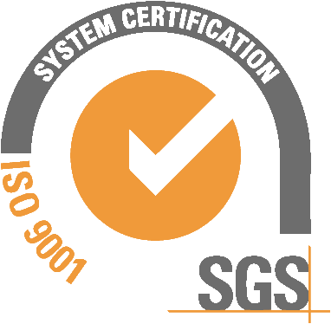
Descripción
5 to 30 mm.

5 to 50 mm.

10 to 60 mm.

Drums with 250 Kg

Big Bag with 1,000 kg
Prompt.
Typical content (% w/w)

