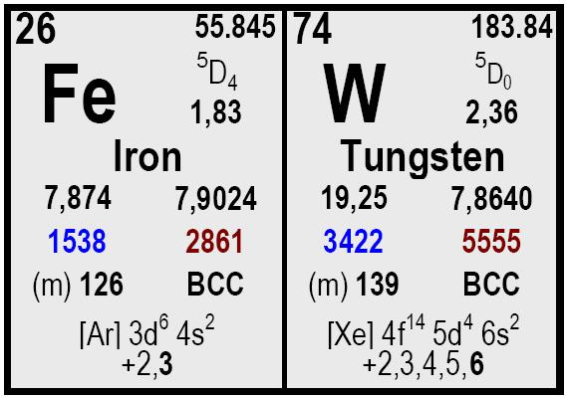

Element | Content
W | 75 – 78
C | 0,20 max.
Cu | 0,15 max.
P | 0,05 max.
Sb | 0,05 max.
Si | 1,5 max.
Mn | 0,25 max.
S | 0,08 max.
As | 0,05 max.
Sn | 0,08 max.

All our products shall be labelled with product name, reference number and net weight. Each delivery is accompanied by a certificate of analysis and the delivery note.

Size Packaging
Delivery time Remarks

Ferro Tungsten
COMETAL, S.A.
• C/José Lázaro Galdiano 4
• 28036 Madrid (Spain)
• Ph: +34 91 4585980
• Fax: +34 91 4585987

• cometal@cometalsa.com
• www.cometalsa.com
• VAT Nr ESA28117026
Your Door to Raw
Materials & Markets
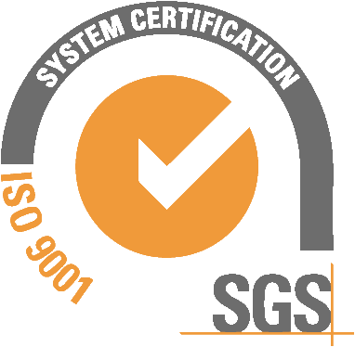
Descripción
10 to 50 mm.

10 to 100 mm.

Drums with 250 Kg

Drums with 500.
Prompt.
Typical content (% w/w)

