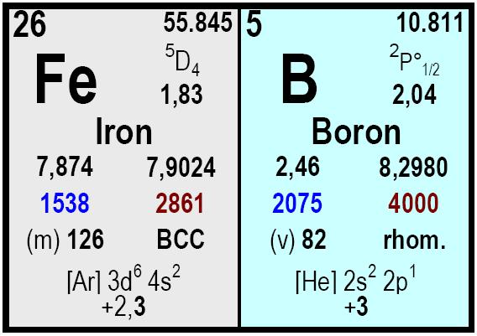

Descripción
Element | Ferro Boron 18-20 | Ferro Boron 14-18
B | 18 – 20 | 14 – 18
Si | 3 max. | 0,5 max.
S | 0,045 max. | 0,20 max.
Al | 0,30 max. | 0,5 max.
C | 0,50 max. | 0,50 max.
P | 0,045 max. | 0,05 max.

0.04 to 2 mm.

5 x 30 mm.

10 to 50 mm.

Bag with 10 Kg.

Drums with 200Kg.

Drums with 250 Kg.

Big bags with 1.000 Kg.

Prompt.
All our products shall be labelled with product name, reference number and net weight. Each delivery is accompanied by a certificate of analysis and the delivery note.

Typical content (% w/w)
Size Packaging
Delivery time Remarks

Ferro Boron Powder / Lumpy
COMETAL, S.A.
• C/José Lázaro Galdiano 4
• 28036 Madrid (Spain)
• Ph: +34 91 4585980
• Fax: +34 91 4585987

• cometal@cometalsa.com
• www.cometalsa.com
• VAT Nr ESA28117026
Your Door to Raw
Materials & Markets


