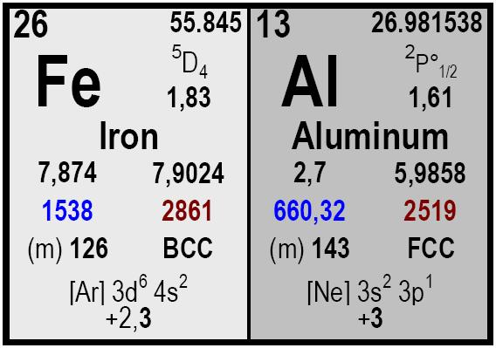

Element | Content
Al | 30 – 35
Si | 1 max.
S | 0,001 max.
Mn | 0,5 max.
C | 0,2 max.
Cu | 0,2 max.
P | 0,009 max.
Fe | Balance.

All our products shall be labelled with product name, reference number and net weight. Each delivery is accompanied by a certificate of analysis and the delivery note.

Size Packaging
Delivery time Remarks

Ferro Aluminium
COMETAL, S.A.
• C/José Lázaro Galdiano 4
• 28036 Madrid (Spain)
• Ph: +34 91 4585980
• Fax: +34 91 4585987

• cometal@cometalsa.com
• www.cometalsa.com
• VAT Nr ESA28117026
Your Door to Raw
Materials & Markets
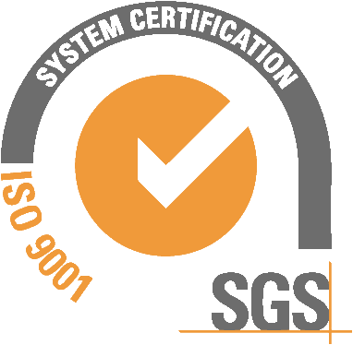
Descripción
5 x 50 mm.
Drums with 500 Kg

Prompt.
Typical content (% w/w)

