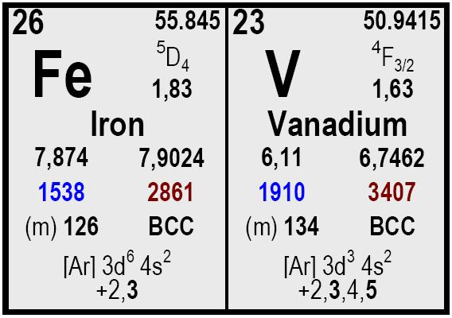


Element | Grade A | Grade B
V | 78 – 85 | 78 – 85
Al | 1,50 max. | 1,50 max.
Si | 1,50 max. | 1,50 max.
C | 0,20 max. | 0,20 max.
P | 0,05 max. | 0,05 max.
S | 0,05 max. | 0,05 max.
Cu | 0,15 max. | 0,15 max.
Mn | 2,50 max. | 2,50 max.
N | 0,30 max. | 0,10 max.

All our products shall be labelled with product name, reference number and net weight. Each delivery is accompanied by a certificate of analysis and the delivery note.

Size Packaging
Delivery time Remarks

Ferro Vanadium
COMETAL, S.A.
• C/José Lázaro Galdiano 4
• 28036 Madrid (Spain)
• Ph: +34 91 4585980
• Fax: +34 91 4585987

• cometal@cometalsa.com
• www.cometalsa.com
• VAT Nr ESA28117026
Your Door to Raw
Materials & Markets
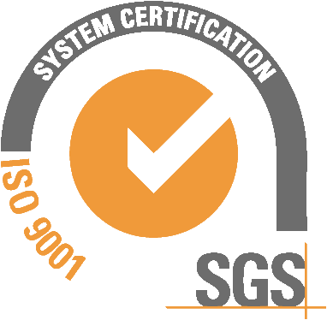
Descripción
5 to 50 mm.

5 to 30.

0 to 5 mm.

Drums with 250 Kg

Big Bag with 1,000 kg

Bags with 10 kg of Vanadium contained in drums of 250 Kg.

Prompt.
Typical content (% w/w)

